Metaphor Guide
Metaphors are one of the most powerful tools you can use to make your content engaging and easy to understand.
By comparing complex ideas to everyday objects or scenarios, you help viewers "get it" quickly.
This guide will show you how to craft metaphors, use them effectively, and avoid common mistakes.
Included in this guide:
- What Are Metaphors?
- Why Metaphors Are Powerful
- When to Use a Metaphor
- How to Create a Metaphor
- Quick Tips for Creating Better Metaphors
- Using Props to Strengthen Metaphors
- Transitions: Introducing Your Metaphor
- Metaphor in Action: Example Breakdown
- Common Mistakes to Avoid
- Using AI to Help You Come Up with a Metaphor
- Final Thoughts
- How to Use Metaphors to Simplify and Engage in Your Videos

What Are Metaphors?
A metaphor compares two unrelated things by stating that one is the other. This comparison simplifies complex problems by relating them to familiar, everyday concepts.
Example:
- Complex Explanation: “Your channel needs consistent parts working together to grow.”
- Metaphor: “YouTube is a chain. If one link breaks, the whole chain fails, and your channel won’t grow.”

Why Metaphors Are Powerful
- Simplifies Complexity: Makes hard-to-understand concepts easy to grasp.
- Increases Engagement: Viewers are more likely to stay tuned if they’re intrigued by a relatable metaphor.
- Boosts Relatability: Helps your audience connect emotionally and intellectually with your message.
- Creates Retention: Metaphors are memorable, so viewers remember your points long after the video ends.

When to Use a Metaphor
- To Simplify: When a concept is too complicated or abstract to explain directly.
- In the Example Section: Metaphors work best when setting up a problem before the payoff.
- To Add Interest: Use them sparingly; if something is already simple, don’t complicate it by forcing a metaphor.

How to Create a Metaphor

Step 1: Define the Problem
- Write down the problem you want to simplify.
- Note how it feels or what it looks like to someone experiencing it.
- Example: The problem is frustration and failure when dating.

Step 2: Define the Solution
- Clearly state the steps or outcomes your solution provides.
- Example: The solution is asking the right questions to land better dates.

Step 3: Find Analogies
- For the problem, think of something in the world that matches its characteristics (e.g., chaos = a storm, failure = a wall).
- For the solution, find something relatable (e.g., success = a bridge, connection = a key).

Step 4: Create the Metaphor
- Combine the problem and solution into a statement:
  - “Winning your dream date is like fishing. To land a great catch, you need the right bait, a strong line, and the ability to throw back the wrong fish.”

Step 5: Test and Refine
- Say it out loud or write it down. Does it make sense? Is it clear?
- Refine until the metaphor feels effortless and relatable.

Quick Tips for Creating Better Metaphors
- Use Familiar Objects or Concepts: The simpler and more common the metaphor, the better it resonates.
- Keep It Short: Avoid overly elaborate metaphors that confuse more than clarify.
- Engage Emotionally: Choose comparisons that evoke feelings your audience can relate to.
- Practice Often: The more you practice, the easier it becomes to generate metaphors on the spot.
- Get Feedback: Share your metaphor with someone to see if it clicks.

Using Props to Strengthen Metaphors
Many problems are invisible or abstract, but props make them tangible.
Example:
- Metaphor: “Trust is like water filling a glass. You need enough to reach the top before you can ask for something in return.”
- Prop: A glass and water visually show the audience what you mean.
Why Props Work:
- They make abstract ideas visible and easy to understand.
- Everyday objects like water, fruit, or cups are relatable and inexpensive tools.

Transitions: Introducing Your Metaphor
Before using a metaphor, always transition smoothly by setting up why it matters.
Example Transition:
- “Let me show you a powerful way to think about building trust, which is the foundation of growing your business.”
Without context, a metaphor can feel random or disconnected. Always explain why the audience should care before diving into it.

Metaphor in Action: Example Breakdown
Scenario 1: Using Water to Explain Trust
- Transition: “Let me give you the other big benefit anyone trying to grow a business would love.”
- Metaphor: “This water is trust, and you need to fill the glass to the top to make sales. The more trust you build, the more willing people are to buy.”
- Application Transition: “But how do you build trust to fill the glass? Here’s how.”
Scenario 2: Selling Without Being Pushy
- Transition: “What’s more important than your selling ratio is this.”
- Metaphor: “Think of your channel as a glass. To sell without ruining your reputation, you need enough goodwill to fill the glass before making an ask.”
- Application Transition: “So how do you know when you’ve built enough goodwill to start selling?”

Common Mistakes to Avoid
- Forcing a Metaphor: If the concept is already simple, a metaphor isn’t necessary.
- Overcomplicating: Keep your metaphor short and relatable—don’t add too many layers.
- Skipping Context: Always transition into your metaphor with a reason why it matters.
- Ignoring Props: Physical props make metaphors clearer and more impactful.

Using AI to help you come up with a metaphor
Keep in mind AI is not to replace our brains BUT it can be a fantastic tool for inspiring us and helping us to make our content more creative.
The free version of ChatGPT is unlikely to do a very good job, it's worth upgrading.
Prompt:
"I need a metaphor to clearly explain [insert detailed concept], ideally avoiding cliches. My audience is diverse, with interests in sports, politics, crypto, whiskey, and music. Could you create three distinct metaphors, each relating specifically to one of these areas? I'm looking for metaphors that strike [specify tone: humorous/serious/inspirational], suited for [specify purpose: educating/persuading/entertaining]. Aim for a balance between brevity and engaging detail to keep them captivated."
Here is what it spat out 👇🏼

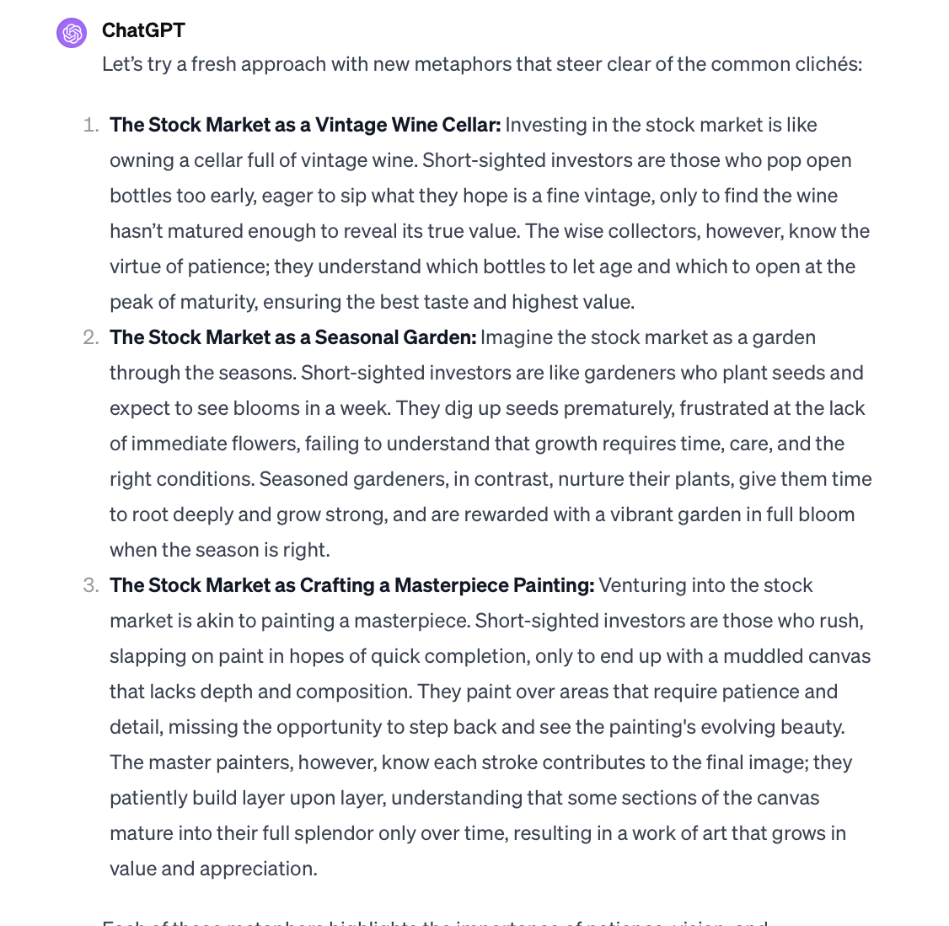

Final Thoughts
Metaphors are transformative tools for simplifying complex ideas and keeping viewers engaged. They can turn abstract problems into relatable, actionable solutions, especially when paired with props.
By practicing and refining your metaphors, you’ll create videos that resonate deeply, retain viewers, and deliver lasting impact.

